WEEK 3 TASK: INITIAL MODEL DEVELOPMENT

Project Title: Student Placement Prediction Using Machine Learning
Name:-Priyanshu Chauhan
Course: B.Tech CSE
Technology: Python, Pandas, Scikit-learn
Model: Logistic Regression

1.Introduction
Student Placement Prediction is a machine learning project that aims to predict whether a student is likely to be placed based on various academic and other relevant factors. Placement prediction can be useful for students, colleges, and placement departments because it can help identify placement trends and provide insights into the factors that may influence a student's placement outcome.
In this project, a Logistic Regression classification model is developed to predict the placement status of students, such as Placed or Not Placed. The model is trained using the cleaned_student_placement.csv dataset, which contains student-related features and their corresponding placement outcomes. The dataset is first preprocessed by handling missing values, encoding categorical features, and scaling numerical features before training and evaluating the model.

2.Objective
The objective of this task is to develop and evaluate an initial machine learning model for predicting student placement outcomes. The project uses Logistic Regression as the baseline classification algorithm to predict whether a student is likely to be placed or not placed based on the available student-related features.
The task also focuses on preprocessing the dataset, dividing it into training and testing sets, training the model, and evaluating its performance using accuracy, precision, recall, F1-score, and confusion matrix. The Logistic Regression model will also be compared with a simple baseline benchmark to understand its effectiveness and identify possible areas for improvement.

3.Problem Statement
tudent placement is influenced by several factors, such as academic performance, internships, projects, skills, and other student-related attributes. However, it can be difficult to determine in advance whether a student is likely to secure a placement using traditional methods alone.
The problem addressed in this project is to develop a machine learning model that can predict a student's placement outcome based on available student data. The model will classify students into two categories: Placed or Not Placed. This can help identify patterns in placement data and provide useful insights for students and educational institutions.

4.Dataset Description
The dataset used for this project is cleaned_student_placement.csv. It contains student-related information that can be used to analyze and predict student placement outcomes. The dataset includes both numerical and categorical features, with the placement status serving as the target variable for the classification model.
Before model training, the dataset was examined for its dimensions, data types, and missing values. Numerical features were identified separately from categorical features. Categorical variables were later encoded using One-Hot Encoding, while numerical features were standardized using StandardScaler as part of the model preprocessing pipeline.
Dataset Information
Attribute | Details
Dataset Name | cleaned_student_placement.csv
Dataset Source | Publicly available student placement dataset
Number of Rows | [your df.shape result]
Number of Columns | [your df.shape result]
Target Variable | [actual target column]
Numerical Features | [actual numerical columns]
Categorical Features | [actual categorical columns]
Missing Values | [actual result]
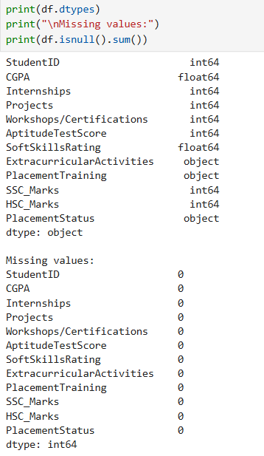
5.Data Preprocessing
Before training the machine learning model, the dataset was preprocessed to ensure that the data was clean and suitable for Logistic Regression. First, missing values were checked, and rows containing missing values were removed using the dropna() method. The target variable representing the student's placement status was separated from the input features.
The dataset contained both numerical and categorical features. Numerical features were standardized using StandardScaler so that features with different ranges could be processed consistently. Categorical features were converted into numerical representations using OneHotEncoder, allowing the Logistic Regression algorithm to process values such as Yes/No or other categorical responses. These preprocessing steps were implemented using a ColumnTransformer and Pipeline, ensuring that the same transformations ere consistently applied during training and testing.
Finally, the processed dataset was divided into 80% training data and 20% testing data. The training data was used to train the Logistic Regression model, while the testing data was kept separate for evaluating the model's performance on unseen data.
6.Exploratory Data Analysis
Exploratory Data Analysis (EDA) was performed to understand the structure, characteristics, and quality of the student placement dataset before building the machine learning model. The dataset was examined using functions such as head(), shape, info(), describe(), and isnull().sum() to identify the number of records, available features, data types, statistical information, and missing values.
The distribution of the placement outcome was also analyzed to understand the number of students who were placed and not placed. Relationships between important features and placement outcomes can be visualized using graphs to identify patterns in the data. This analysis helps in understanding the dataset and selecting appropriate preprocessing and modeling techniques.
7.Machine Learning Algorithm Selection
Why Logistic Regression?
Logistic Regression was selected for this project because Student Placement Prediction is a binary classification problem, where the expected outcome is whether a student will be Placed or Not Placed. The algorithm is well suited for predicting categorical outcomes and is commonly used as a baseline classification model.
Logistic Regression is computationally efficient, relatively easy to interpret, and works well with appropriately processed numerical and categorical features. It also produces probability-based predictions, which can provide an indication of how likely a student is to be placed. Therefore, it provides a suitable starting point for developing and evaluating the initial Student Placement Prediction model.
8.Train-Test Split
The dataset was divided into two separate subsets using the train_test_split() function from Scikit-learn. 80% of the data was used for training the model, while the remaining 20% was used for testing. The training dataset was used to learn patterns and relationships between the student features and placement outcomes, while the testing dataset was used to evaluate how well the trained model performs on previously unseen data.
A random_state value of 42 was used to ensure that the same split can be reproduced whenever the code is executed. The stratify=y parameter was also used to maintain a similar distribution of the placement classes in both the training and testing datasets.

9. Baseline Benchmark
To evaluate whether the Logistic Regression model is learning meaningful patterns from the dataset, a simple baseline model was created using Scikit-learn's DummyClassifier. The Dummy Classifier does not learn relationships between the input features and the target variable. Instead, it predicts the most frequent class in the training dataset.
The accuracy of the Dummy Classifier is then compared with the accuracy of the Logistic Regression model. If Logistic Regression performs significantly better than the baseline, it indicates that the model is learning useful patterns from the student data rather than simply predicting the majority class.
10. Model Evaluation
The performance of the Logistic Regression model was evaluated using standard classification metrics. Since the objective is to predict whether a student will be placed or not placed, accuracy, precision, recall, F1-score, and confusion matrix were used to measure the model's performance.
10.1 Accuracy
Accuracy represents the proportion of correctly classified students out of the total number of students in the testing dataset. It provides an overall measure of how well the model performs.
10.2 Precision
Precision measures how many of the students predicted as placed were actually placed. A higher precision indicates that the model produces fewer false positive predictions.
10.3 Recall
Recall measures how many of the students who were actually placed were correctly identified by the model. A higher recall means the model is better at identifying students who are actually placed.

10.4 F1-Score
The F1-score is the harmonic mean of precision and recall. It provides a balanced measure when both precision and recall are important.
10.5 Confusion Matrix
A confusion matrix shows the number of correct and incorrect predictions made by the model. It contains:
- True Positive (TP): Correctly predicted placed students.
- True Negative (TN): Correctly predicted not-placed students.
- False Positive (FP): Students predicted as placed but actually not placed.
- False Negative (FN): Students predicted as not placed but actually placed.

11.Cross-Validation
To further validate the performance of the Logistic Regression model, 5-fold cross-validation was performed. In this technique, the dataset is divided into five approximately equal parts, or folds. The model is trained on four folds and evaluated on the remaining fold. This process is repeated five times so that each fold is used once as the validation set.
The accuracy scores from all five folds are then averaged to obtain the mean cross-validation accuracy. This provides a more reliable estimate of the model's performance and reduces dependence on a single train-test split.

Code Section
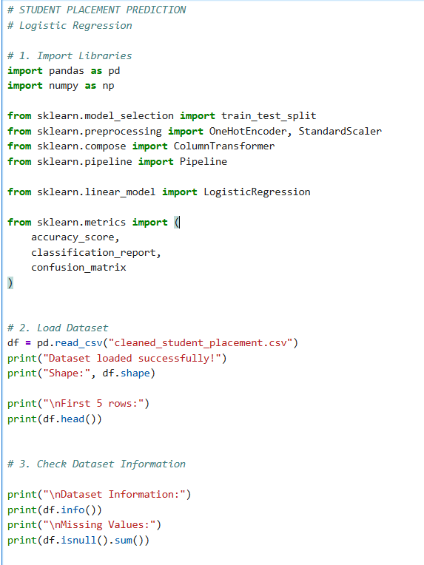
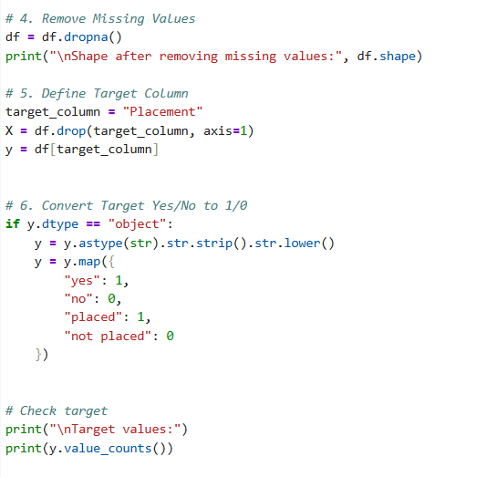
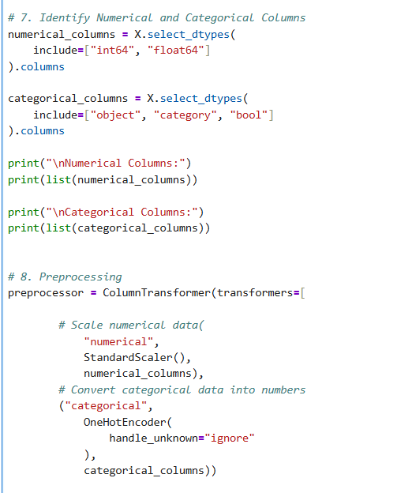
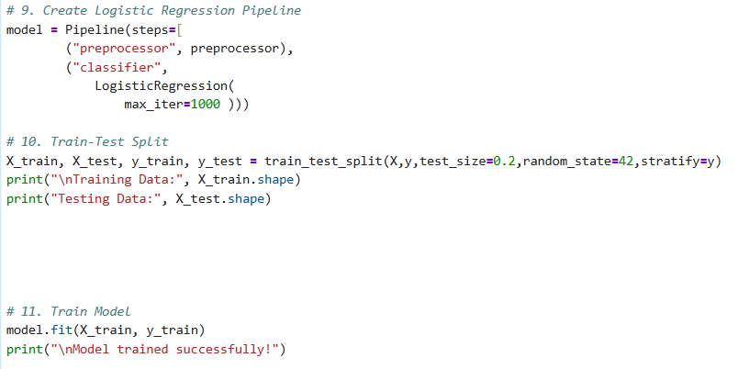
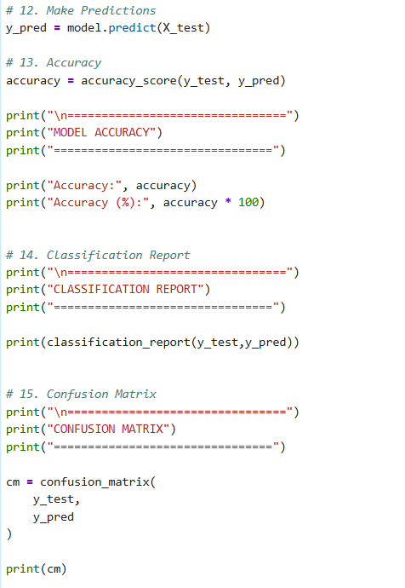

17. Findings and Analysis
The initial Logistic Regression model demonstrates that machine learning can be used to predict student placement outcomes based on the available student-related features. The model was successfully trained after preprocessing the numerical and categorical variables.
The test results show an accuracy of XX%, while the precision, recall, and F1-score provide further information about the classification performance. The comparison with the Dummy Classifier helps determine whether the Logistic Regression model is actually learning useful patterns from the dataset.
The cross-validation results provide additional evidence about the consistency of the model. Overall, the initial model provides a useful baseline for the Student Placement Prediction project and can be further improved using more advanced machine learning techniques.
18. Assumptions
The following assumptions were made during the development of the model:
- The dataset contains sufficiently reliable and representative student information.
- The placement status in the dataset accurately represents the actual placement outcome.
- The selected features contain useful information for predicting placement.
- The training and testing datasets are representative of the overall dataset.
- Removing rows containing missing values does not significantly affect the overall distribution of the dataset.
- The historical patterns in the dataset can provide useful information for predicting placement outcomes for similar students.

19. Limitations
Although the initial model provides useful results, there are some limitations:
- The performance of the model depends heavily on the quality and size of the dataset.
- Logistic Regression is a relatively simple classification algorithm and may not capture complex relationships between features.
- Removing missing values may result in some useful records being excluded.
- The model's performance may be affected if the placement classes are imbalanced.
- The available features may not include all factors that influence student placement.
- The model should not be considered a guaranteed predictor of an individual's actual placement outcome.

20. Potential Areas for Improvement
The model can be improved in future stages of the project by:
- Testing additional algorithms such as Random Forest, Decision Tree, Support Vector Machine, and XGBoost.
- Hyperparameter tuning to identify better model parameters.
- Feature engineering to create more meaningful features from the existing data.
- Using a larger dataset to improve the model's ability to generalize.
- Handling class imbalance if the number of placed and not-placed students is significantly different.
- Performing additional cross-validation and comparing different evaluation metrics.
- Feature selection to identify the most important factors affecting placement.
- Comparing multiple models to select the best-performing approach.
21. Conclusion
The initial machine learning model for Student Placement Prediction was successfully developed using Logistic Regression. The dataset was preprocessed by handling missing values, separating numerical and categorical features, applying feature scaling, and encoding categorical variables.
An 80:20 train-test split was used to train and evaluate the model. The model was evaluated using accuracy, precision, recall, F1-score, and a confusion matrix. A Dummy Classifier was also used as a simple benchmark, while five-fold cross-validation was performed to assess the consistency of the model.
The initial results demonstrate the feasibility of using machine learning for student placement prediction. However, further improvements through feature engineering, hyperparameter tuning, larger datasets, and advanced machine learning algorithms could potentially improve the model's performance.

